**1)** Anish Manandhar

W0658737

**2)** First off, the project was divided into 3 phases. The first phase was about creating couple endpoints, making sure the program runs and run it locally. Later, Heroku was added to the program which let us deploy it. Heroku is one of the simplest and easiest cloud services that let us deploy, monitor and scale web applications and mobile applications. Installing Heroku is all it takes to host the program. One the project was up and running and was deployed we move on to the second phase where couple more actions than just GET, and POST were added, like PUT and DELETE. Once it was running locally we deploy it using Heroku. Now comes the third phase where it says an adapter should be added. That means there should be couple more endpoints, GET and POST, which are capable to converting JSON to XML and vice versa. Both the methods were calling the previous ‘normal’ GET and POST methods, so we had to do http requests to those endpoints and responses were received so that the conversion was possible. There are four basic operation or actions associated with the Web service model: publish, find, bind and service request/response. All of them were mostly handled by Heroku as soon as we made requests to service.

3) GET by ID 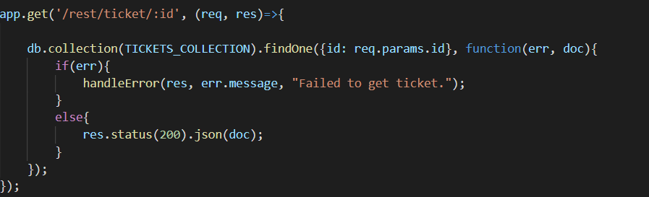

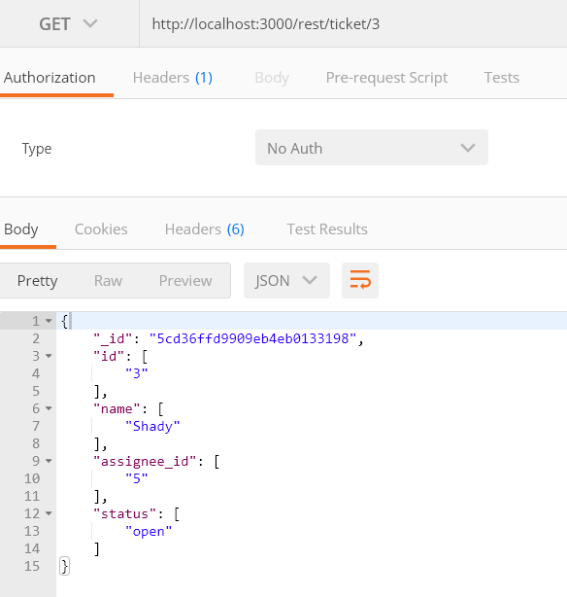

POST

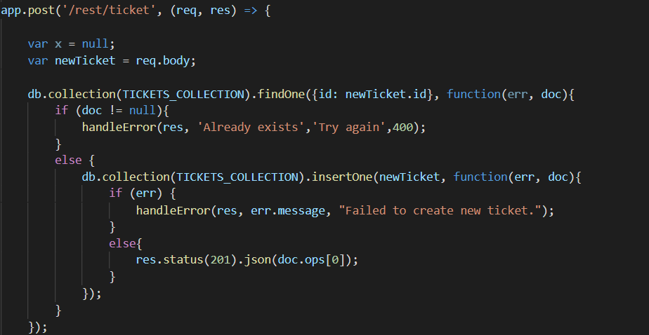

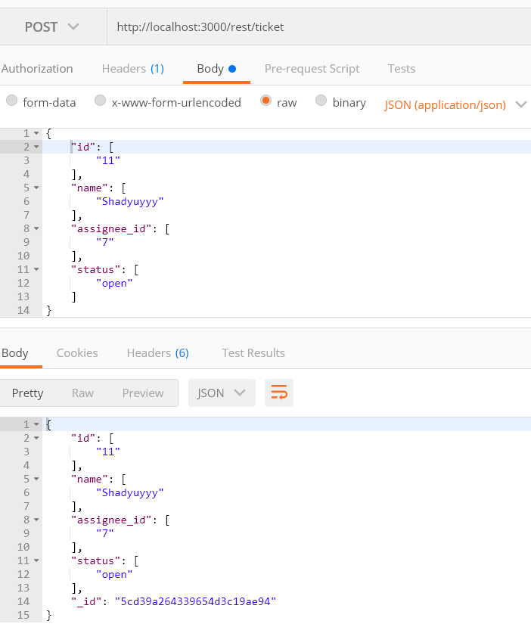

GET (into xml)

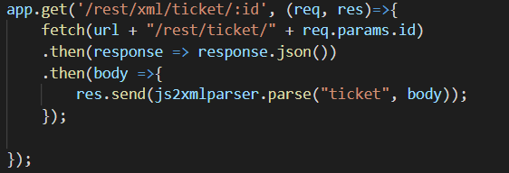

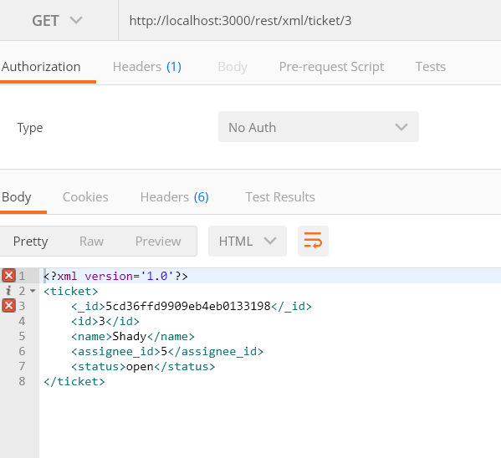

POST(xml to JSON)

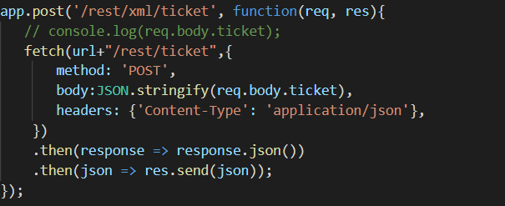

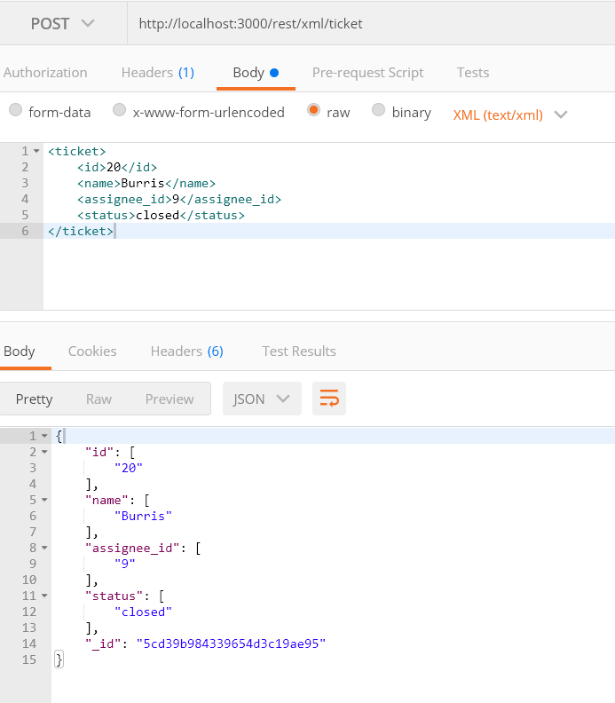

* I would say I was quite successful about completing what was asked in the project. I could have done a lot more if only I had time or if we had started the project not at the end of the semester. There were quite a lot of hurdles I faced in the project as I had never done node.js before. I also had problems with deployment. The other problem was calling the existing endpoint in a new one. I had to do a lot of research and spend a lot of time asking for help and just googling everything. I somehow figured Heroku wasn’t bad at all and axios or fetch method could handle all the http requests and they helped me a lot. Yes, I might actually be working on the project on my own and go even further where you can do a lot more stuffs than 4 methods we added originally. Adding users and buying tickets might be the next stop.